The number of ways the letters in "FACETIOUS" are arranged so that all the vowels are together.

The word "FACETIOUS" has 9 letters. The vowels are A, E, I, O, U (5 vowels). The consonants are F, C, T, S (4 consonants).

**Step 1: Treat the vowels as a single unit.**

Since all the vowels must be together, we can consider them as one combined entity (AEIOU).

**Step 2: Arrange the unit of vowels and the consonants.**

Now we have this unit of vowels (AEIOU) and the 4 consonants (F, C, T, S).

This gives us a total of 1 (vowel unit) + 4 (consonants) = 5 items to arrange.

These 5 items can be arranged in 5! (5 factorial) ways:

5! = 5 × 4 × 3 × 2 × 1 = 120 ways.

**Step 3: Arrange the vowels within their unit.**

The 5 vowels (A, E, I, O, U) within their unit can be arranged among themselves. Since all the vowels are distinct, they can be arranged in 5! (5 factorial) ways:

5! = 5 × 4 × 3 × 2 × 1 = 120 ways.

**Step 4: Multiply the number of arrangements.**

To get the total number of ways all the vowels are together, we multiply the number of ways to arrange the vowel unit and consonants by the number of ways to arrange the vowels within their unit:

Total arrangements = (Arrangements of vowel unit and consonants) × (Arrangements of vowels within the unit) Total arrangements = 5! × 5!

If five alphabets are selected at random from the word "FACETIOUS" then in how many possible ways three vowels and two consonants can be selected?

**Number of ways to select 3 vowels from 5** = C(5, 3) = 5! / (3! * (5-3)!) = 5! / (3! * 2!) = (5 * 4 * 3!) / ((3!) * (2 * 1)) = (5 * 4) / 2 = 20 / 2 = 10.

We need to select 2 consonants from the 4 available consonants. The number of ways to do this is:

**Number of ways to select 2 consonants from 4** = C(4, 2) = 4! / (2! * (4-2)!) = 4! / (2! * 2!) = (4 * 3 * 2!) / ((2 * 1) * (2 * 1)) = (4 * 3) / (2 * 1) = 12 / 2 = 6.

**Total number of ways** = 10 × 6 = 60.

**How many unique ways are there to arrange the letters in the word PRETTY?**

Using this method, the total number of arrangements is 6•5 •4 •3 •2 • 1 = 720. Another way of writing this is 6!, or 6 factorial, but this isn't quite the right answer.

Using the above method, we assumed that all the letters were unique. But they're not! There are 2 Ts, so we're counting every permutation multiple times. So every time we have these 2 permutations:

PRETYT

PRETYT

We actually should have only one permutation.

Notice that we've overcounted our arrangements by 2!. This is not a coincidence! This is exactly the number of ways to permute 2 objects, which we were doing with the non-unique Ts. To address this overcounting, we need to divide the number of arrangements we counted before by 2!.

When we divide the number of permutations we got **by the number of times we're overcounting** each permutation, we get

6!/2! = 720/2 = 360

Our probability will look something like this:

**P = # of correct groups or sequences/# of all possible groups or sequences**

Since repeated digits aren't allowed, we can use permutations and combinations to help us find the counts in the numerator and/or denominator. The most important thing is to distinguish whether or not order matters in the given scenario:

• If order matters, we use **permutations**.

• If order doesn't matter, we use **combinations**.

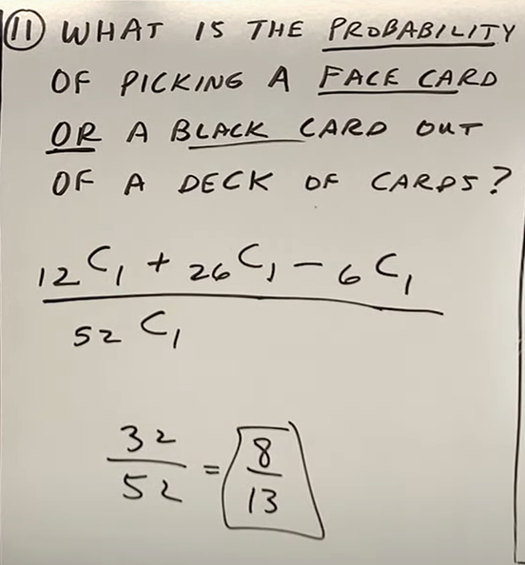

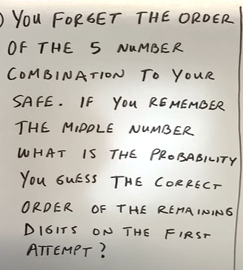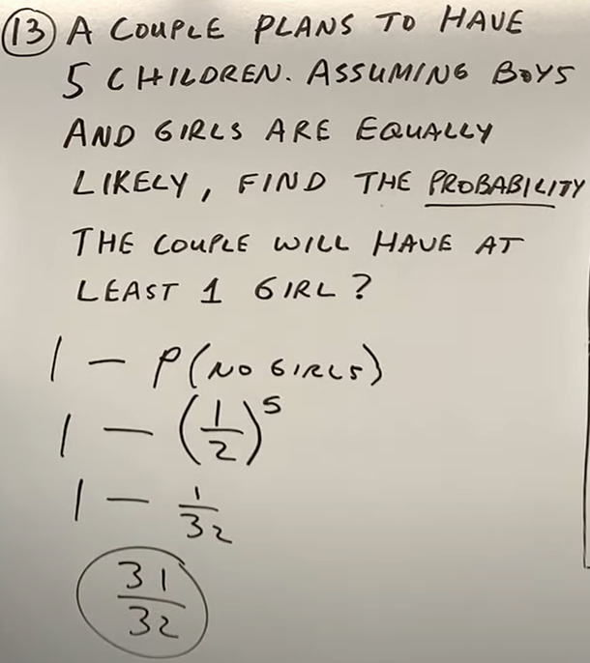

In this question, the person remembers all the 5 digits, but he forgot the order. He only knows the middle number.

Another answer can be: **1 divided by 4P2 * 2P2**



Total number of television sets in the shipment = 12

Number of defective television sets = 3

Number of non-defective television sets = 12 - 3 = 9



